

Basic Electrical and Electronics

Engineering Lab WorkBook

**SHAVETA ARORA VANDANA KHANNA PAVAN KHETRAPAL NARESH KUMARI**

**School of Engineering & Technology *Department of Electrical, Electronics and Communication Engineering***

Name AMAN THAKUR Roll No. 20CSU336 Branch CSE Batch G

**The NorthCap University**

**Gurugram, Haryana**

**INDEX** Roll No: .......................

|  |  |  |  |  |
| --- | --- | --- | --- | --- |
| **S.**  **No.** | **Name of Experiment**  (In the sequence of performance) | **Date of Performance** | **Total Marks**    **(10)** | **Faculty’s Signature with Date** |
| 1 | **Familiarization with CRO, DSO, Function generator, Power supplies, Multimeter, Bread board, Passive components.** | 15 March 2021 |  |  |
| 2 | Study and Analysis of Kirchhoff’s Law. | 26 March 2021 |  |  |
| 3 | TO STUDY AND ANALYSIS OF THEVENIN’S THEORM AND MAXIMUM POWER TRANSFER THEORM. | 9 April 2021 |  |  |
| 4 | To study and analysis of Superposition theorem. | 23 April 2021 |  |  |
| 5 |  |  |  |  |
| 6 |  |  |  |  |
| 7 |  |  |  |  |
| 8 |  |  |  |  |
| 9 |  |  |  |  |
| 10 |  |  |  |  |
| 11 |  |  |  |  |
| 12 |  |  |  |  |
| 13 |  |  |  |  |
| 14 |  |  |  |  |
| 15 |  |  |  |  |

# Experiment No.- 01

##### Date 22 March 2021

**Objective:**

**Familiarization with CRO, DSO, Function generator, Power supplies, Multimeter, Bread board, Passive components.**

**Definitions / Theory:**

1. **CRO:**

The cathode ray oscilloscope is an electronic test instrument, it is used to obtain waveforms when the different input signals are given. In the early days, it is called as an Oscillograph. The oscilloscope observes the changes in the electrical signals over time, thus the voltage and time describe a shape and it is continuously graphed beside a scale. By seeing the waveform, we can analyze some properties like amplitude, frequency, rise time, distortion, time interval, and etc.

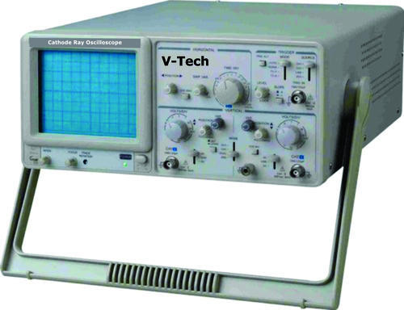

*Cathode Ray Oscilloscope*

1. **DSO**:

The DSO is also one type of oscilloscope, used to display the waveform, but the difference between CRO and DSO is that in DSO, the digital signal is converted into analog and that analog signal will be displayed on the screen of the digital storage oscilloscope. In the conventional CRO, there is no procedure for the storage of the waveform but in DSO, there is a digital memory that is going to store the digital copy of the waveform.

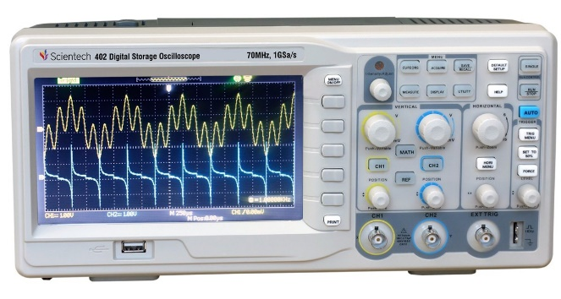

*Digital Storage Oscilloscope*

1. **Function** **Generator**:

The function generator is defined as a type of device which produces various types of waveforms as its output signals. The common waveforms generated by this generator are sine wave, square wave, triangular wave, and sawtooth waves. The waveforms of these frequencies may be adjusted from hertz to a hundred kHz. This generator is considered as the most versatile instrument in the electrical and electronics laboratory because the waveforms generated by this generator have applications in different areas. The analog function generators and digital function generators are types of function generators.

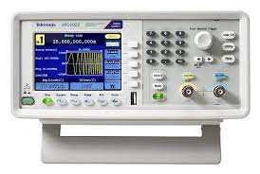

*Function Generator*

1. **Power Supplies:**

A power supply basically converts AC (from wall outlet) to unregulated DC, and reduces the voltage using a step-down transformer.

There are two types of AC power supplies, unregulated and regulated.

Regulated power supply has the ability to provide constant voltage throughout while unregulated power supply doesn’t.

*Power* *Supply*

1. **Multimeter**

A Multimeter is an electronic instrument, every electronic technician and engineer’s widely used piece of test equipment. A multimeter is mainly used to measure the three basic electrical characteristics of voltage, current, and resistance. It can also be used to test continuity between two points in an electrical circuit.

The multimeter has multi functionalities like, acts like ammeter, voltmeter, and ohmmeter. It is a handheld device with positive and negative indicator needle over a numeric LCD digital display. Multimeters can be used for testing batteries, household wiring, electric motors, and power supplies.

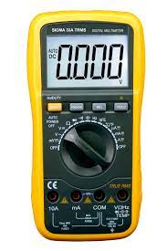

*Multimeter*

1. **Breadboard**

A breadboard is made with a plastic material in a rectangular shape with a huge number of tiny holes. These holes let you simply place an electronic component to build an electronic circuit that is assembled with various components. The connections on the breadboard are not stable, so it is very simple to remove a component if you make a wrong connection. Breadboards are very great for beginners who are new to electronics. By using this, you can make different electronic projects.

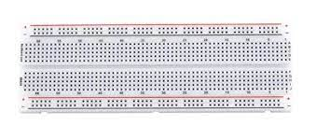

*Breadboard*

1. **Passive Components :**

Those components in an electric circuit which do not generates power rather distributes, stores, or releases it. Some examples of passive components are ***Resistors, capacitors and coils.***

**Resistor:**

It is a basic two-terminal electrical and electronic component used to restrict the current flow in a circuit. The resistance toward the flow of current will result in the voltage drop. These devices may provide a permanent, adjustable resistance value. The value of resistors can be expressed in Ohms.

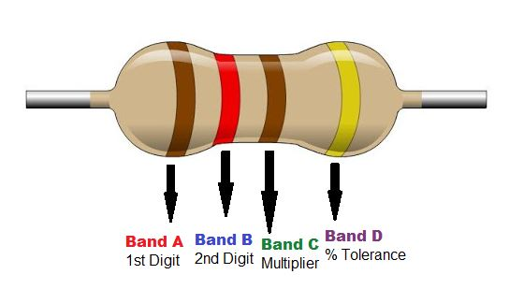

*Resistor*

**Capacitors**:

A capacitor is mainly used for storing electric energy like electrostatic energy. Once there is a need to enhance more energy to store capacity, then an appropriate capacitor with increased capacitance can be necessary. The designing of a capacitor can be done using two metal plates which are allied in parallel & divided through a dielectric medium such as mica, glass, ceramics, etc.

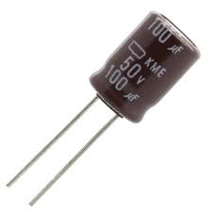 *Capacitor*

**Inductors**:

An inductor is also named as a reactor, coil and choke. It is a two terminal electrical component used in various electrical and electronic circuits. An inductor is used to store energy in the form of a magnetic field. It comprises of a wire, usually twisted into a coil. When a current pass through it, energy stored temporarily in the coil. It is measured in Henry (H).

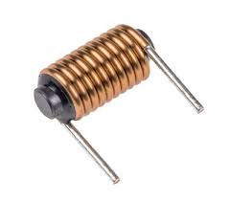

*Inductor* *Coil*

**Practical Diagram**

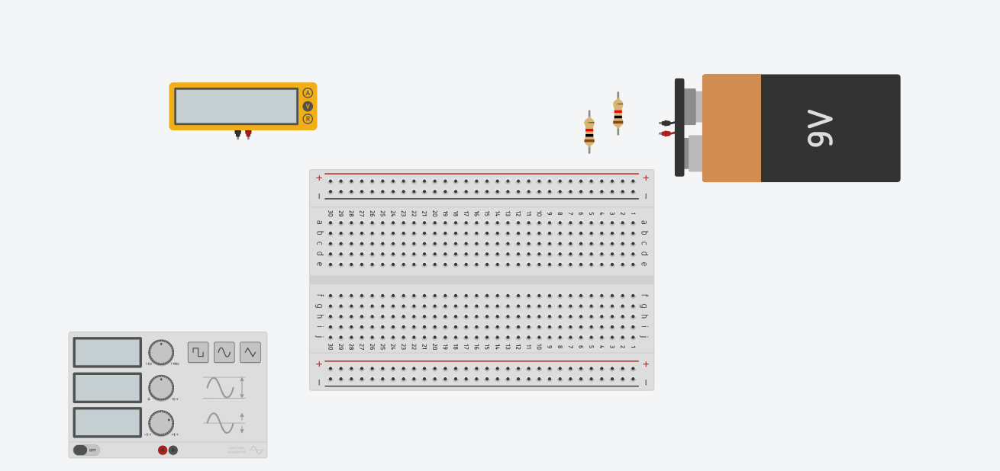

**ANSWERS TO QUESTION BANK**

**Q1)** What do you mean by active and passive components?

* **Active Components**: Those elements of an electrical circuit which can provide or delivers energy to the circuit. For e.g., Transistors, logic gates, Zener diode, etc.
* **Passive Components**: Those devices which do not require any external sources for operation and stores energy in form of voltage or current. For e.g., resistors, capacitors, inductors.

**Q2)** What is ohm’s law?

* It states that the voltage or potential difference through a conductor is directly proportional to current flowing through it.

**V=IR** where **R** is constant of proportionality, known as resistance.

**Q3)** Find the value of resistance with 4 types of strips of brown, black, red, and golden.

* 10x102+-5%

**Q4)** What is multimeter? Give its applications.

A multimeter is mainly used to measure the three basic electrical characteristics of voltage, current, and resistance. It can also be used to test continuity between two points in an electrical circuit.

The multimeter has multi functionalities like, acts like ammeter, voltmeter, and ohmmeter. Multimeters can be used for testing batteries, household wiring, electric motors, and power supplies.

**Q5).** What is the difference between alternating and direct current?

Alternating Current:

The flow of charges that reverses its flowing direction repeatedly, many times a second on a regular interval. AC is mostly supplied in houses, buildings, etc.

Direct Current:

Unlike alternating current (AC), this type of current flows in only one particular direction, and not reverses it over a period of time.

Many of the electrical devices we used are run on Direct current (DC).

**Marks for write-up and experiment performance (Max. Marks )__________**

**Quiz Marks (Max. Marks ) ________**

**Faculty signature with Date Total Marks**

# Experiment No.- 02

##### Date 22 March 2021

**OBJECTIVE:** **To perform and verify Kirchhoff’s Law**

**To perform maximum power transfer theorem and proof that maximum power will be transferred when load resistance is equal to total internal resistance of the network**

**Hardware:** Function Generator, Power Supplies, Multimeter, Breadboard And Passive Components.

**Software:** Tinker Cad

**Theory:** There are two fundamental laws, which are applicable to electrical DC and AC network. These are Kirchhoff’s current law (KCL) and Kirchhoff’s voltage law (KVL).

1. KVL: it deals with the conservation of energy, it states that algebraic sum of all EMF sources in a closed loop is zero.

**Circuit Diagram and calculations:**

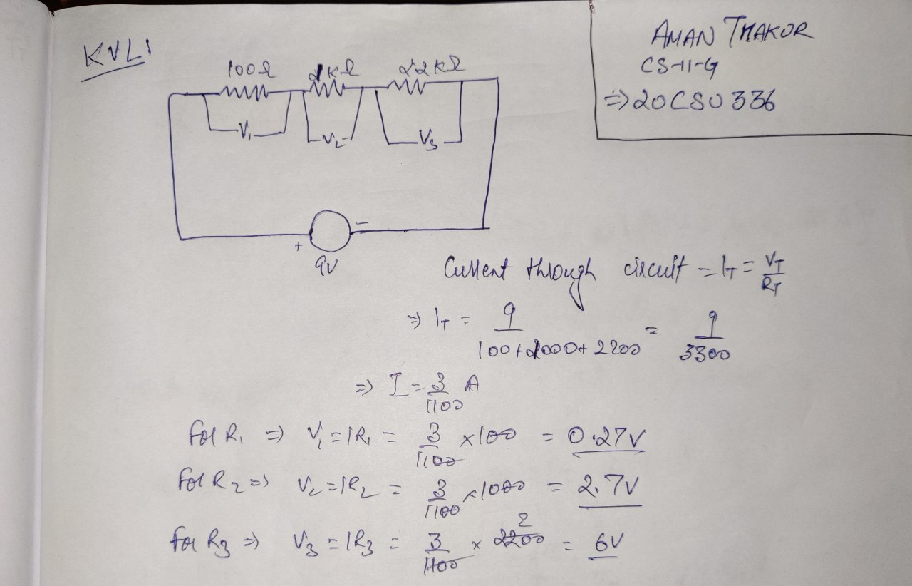

**Practical Diagram:**

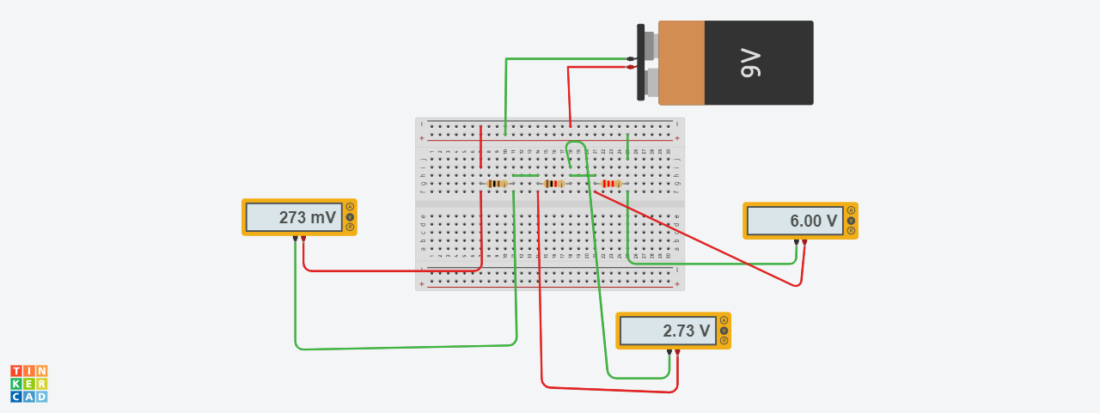

**Table of experimental results**

**KVL**

|  |  |  |  |  |  |  |  |  |  |  |  |
| --- | --- | --- | --- | --- | --- | --- | --- | --- | --- | --- | --- |
| **Sr. No.** |  | **Input Voltage V (V)** | **Total Current I (A)** | | **V1 (V)** | | **V2 (V)** | | **V3 (V)** | | **Remarks** |
|  | **Theo** | **Prac** | **Theo** | **Prac** | **Theo** | **Prac** | **Theo** | **Prac.** |
|  |  | **9V** | **3/1100A** | **3/1100A** | **0.27V** | **0.27V** | **2.7V** | **2.7V** | **6V** | **6V** |  |

1. **KCL :** The algebraic sum of all currents entering and exiting a node must equal zero.

**Circuit diagram and Calculations:**

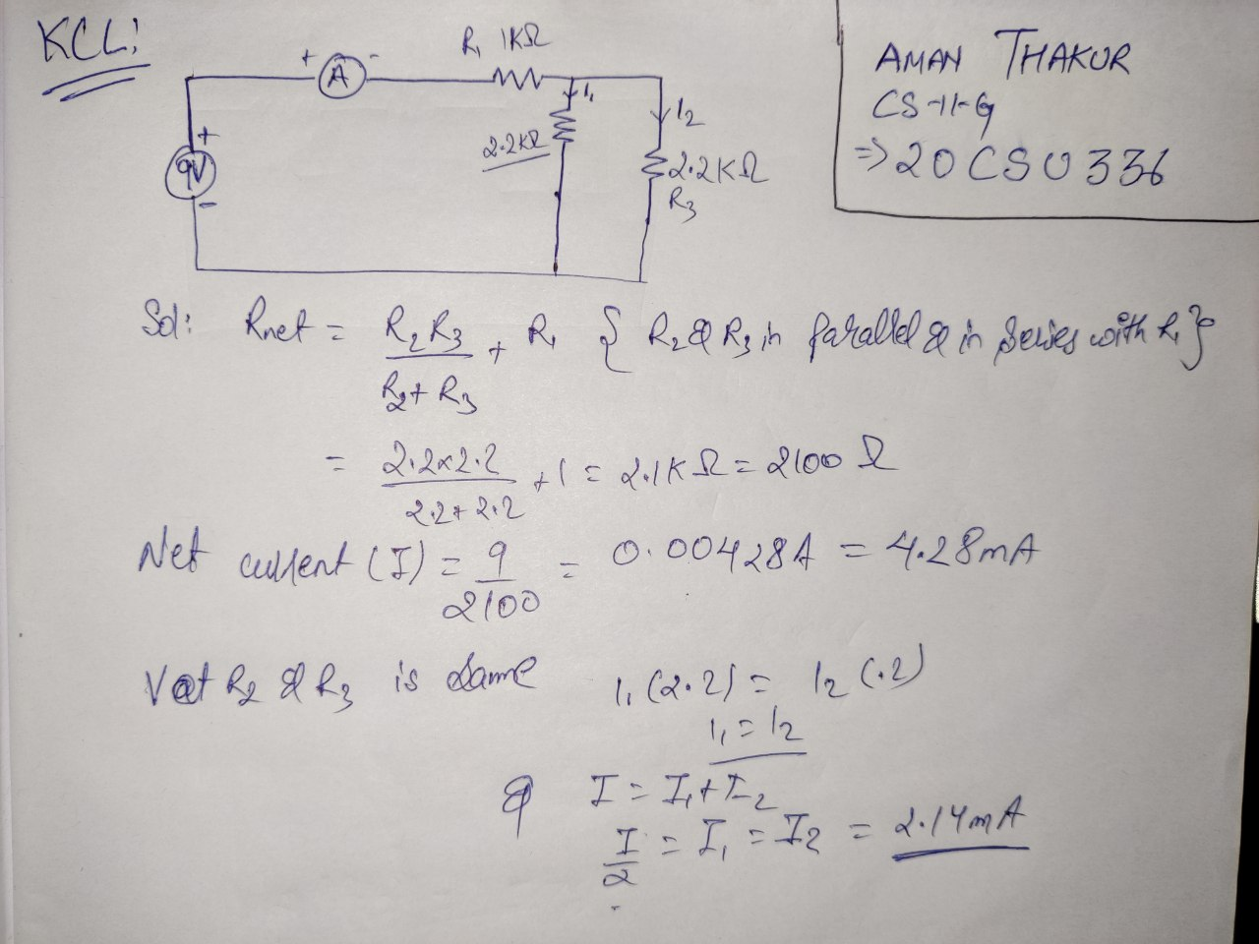

**Practical Diagram:**

**KCL**

|  |  |  |  |  |  |  |  |  |
| --- | --- | --- | --- | --- | --- | --- | --- | --- |
| **Sr. No.** | **Input Voltage V (V)** | **Total Current I (A)** | | **I1 (V)** | | **I2 (V)** | | **Remarks** |
| **Theo** | **Prac** | **Theo** | **Prac** | **Theo** | **Prac** |
| **1** | **9V** | **4.28mA** | **4.28mA** | **2.14mA** | **2.14mA** | **2.14mA** | **2.14mA** |  |
|  |  |  |  |  |  |  |  |  |

**Conclusion:** KCL is verified.

KVL is verified.

**Answers to Quiz**

**Q1)** What do you mean by the term node in reference to electric circuit?

A node is the point of connection between two or more branches. A node is usually indicated by a dot in a circuit.

**Q2**) What is the difference between a mesh and a loop?

* A loop is a closed path in a circuit where two nodes are not traversed twice except the initial point, which is also the final one. But in a loop other paths can be included inside.

• A mesh is a closed path in a circuit with no other paths inside it. In other words, a loop with no other loops inside it.

**Q 3)** What do you mean by an active circuit?

Active circuit is that circuit which consists of at-least one active component like Zener diode, transistors, etc.

**Q4**) Define KCL and KVL.

* KCL: The algebraic sum of all currents entering and exiting a node must equal zero.
* KVL: it deals with the conservation of energy, it states that algebraic sum of all EMF sources in a closed loop is zero.

**Q5)** Give the examples of active and passive elements.

* Active elements:
  + Zener diode
  + Transistors
  + OP lamps
  + Logic Gates
* Passive elements:
  + Resistors
  + Capacitors
  + Inductors

**Marks for write-up and experiment performance (Max. Marks )__________**

**Quiz Marks (Max. Marks ) ________**

**Faculty signature with Date Total Marks**

# Experiment No.- 3

# Objective: To study and analysis of Thevenin’s theorem and maximum power transfer theorem

# Software Used: TinkerCad

# Theory:

# Thevenin’s theorem: According to it, any circuit can be converted into Thevenin Equivalent Circuit having the Thevenin voltage source (Vth) in series with Thevenin Resistance (Rth) and load resistance (RL). It states that

# *Any linear circuit containing several voltages and resistances can be replaced by just one single voltage in series with a single resistance connected across the load*

# *.*

# Maximum Power Transfer theorem (for D.C): According to Maximum Power Transfer theorem, the load resistance will extract the maximum power from the source when *RL=* *RS* where RS is internal resistance of network RL.

# Theoretical Calculations:

# Thevenin’s theorem:

# 

# Maximum Power Transfer theorem

# Practical Implementation:

# Thevenin’s theorem:

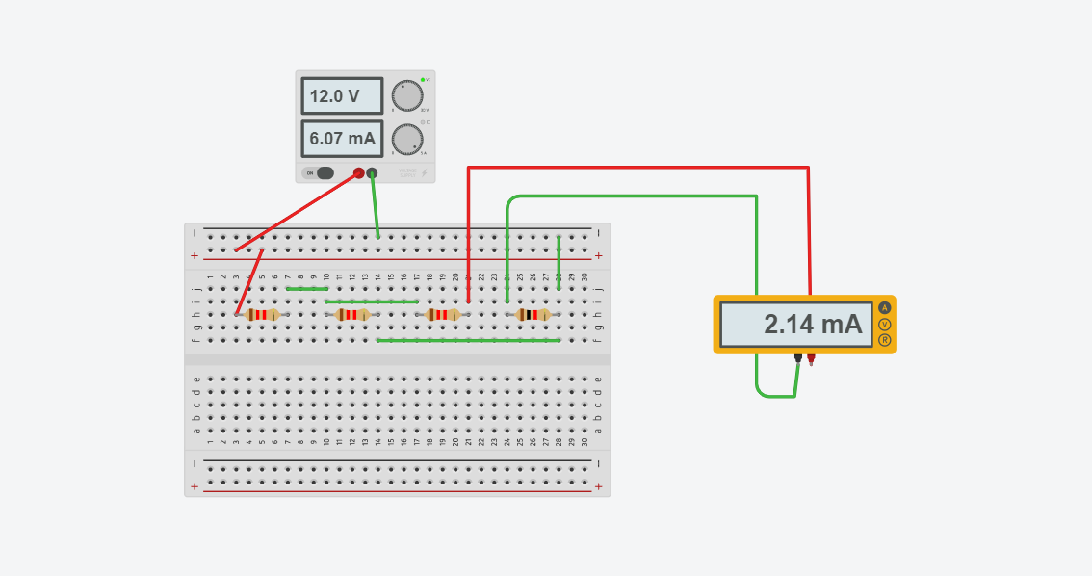

# 

*For* *Vth*

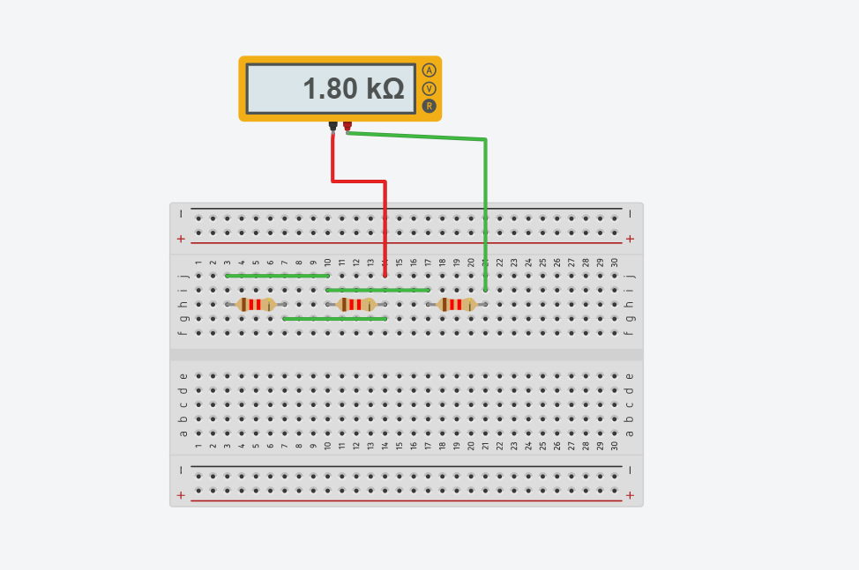

*For* *Rth*

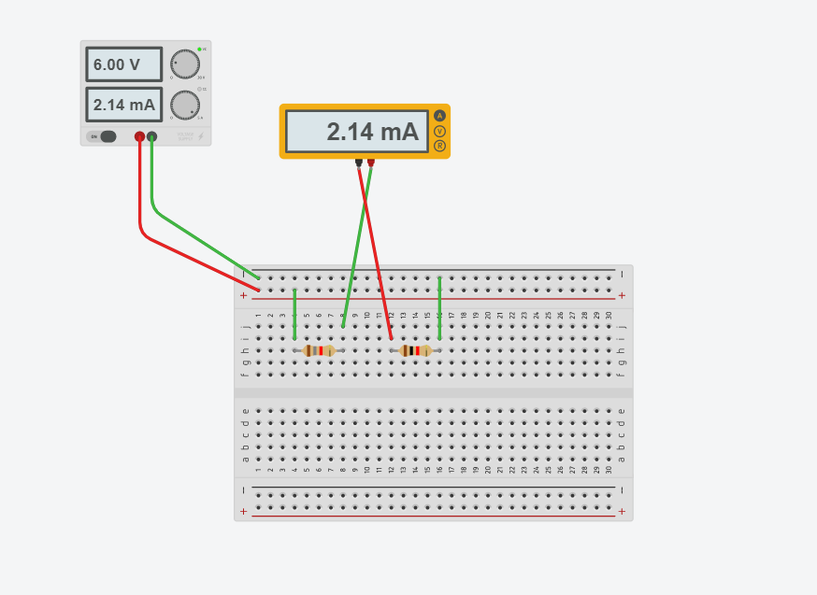

*Thevenin Equivalent Circuit*

# Maximum Power Transfer theorem

# Observation Table:

# For Thevenin’s theorem:

|  |  |  |  |  |  |  |  |  |
| --- | --- | --- | --- | --- | --- | --- | --- | --- |
| Sr. No. | IL(A)  Basic ckt. | Vth (V) | | Rth (ohms) | | IL(A)Equ. | | Remarks |
| Theo | Prac | Theo | Prac | Theo | Prac |  |
| 1. | 6.07 | 12 | 6 | 1.2 | 1.2 | 2.14 | 2.14 |  |
| 2. | 0.5 | 12 | 6 | 1.2 | 1.2 |  |  |  |
| 3. | 2.14 | 6 | 6 | 1.2 | 1.2 | 2.14 | 2.14 |  |

# For Maximum Power Transfer theorem:

|  |  |  |  |  |
| --- | --- | --- | --- | --- |
| Sr. No. | RL | IL | VL | PL = IL*VL |
| 1. | 0.1(kiloohm) | 3.91(miliampere) | 391(millivolt) | 1.28*10-3 |
| 2. | 1.0(kiloohm) | 2.81(miliampere) | 2.81(volt) | 7.86*10-3 |
| 3. | 1.2(kiloohm) | 2.65(miliampere) | 3.18(volt) | 8.42*10-3 |
| 4. | 1.8(kiloohm) | 2.25(miliampere) | 4.05(volt) | 9.11*10-3 |
| 5. | 2.2(kiloohm) | 2.04(miliampere) | 4.50(volt) | 9.18*10-3 |
| 6. | 4.7(kiloohm) | 1.30(miliampere) | 6.13(volt) | 7.96*10-3 |
| 7. | 10(kiloohm) | 738(microampere) | 7.38(volt) | 5.44*10-3 |

# IL max=2.06A

# PL max = 9.15 Watt

# Rth=2.2kohm

**Conclusion:** Thus, Thevenin’s theorem and maximum power transfer theorem is verified.

# Answers to Quiz

Q1. State Thevenin’s theorem.

# According to it, any circuit can be converted into Thevenin Equivalent Circuit having the Thevenin voltage source (Vth) in series with Thevenin Resistance (Rth) and load resistance (RL). It states that *Any linear circuit containing several voltages and resistances can be replaced by just one single voltage in series with a single resistance connected across the load.*

Q2. State maximum power transfer theorem.

* According to Maximum Power Transfer theorem, the load resistance will extract the maximum power from the source when ***RL= RS*** where RS is internal resistance of network RL.

# Q3. What do you mean by Open Circuit Voltage?

# Open circuit voltage (VOC) is the difference of electric potentials between two terminals of a device when disconnected from any circuit. No external load connected. No external current flows between the terminals.

# Q4. What are the practical applications of MPTT?

# It is used in Radio Communications, where the power amplifier transmits the maximum amount of signal to the antenna if and only if load impedance in the circuit is equal to the source impedance.

* It is also applied in audio systems, where the voice is to be transmitted to the speaker. The amplifier amplifies the maximum amount of voice when the load impedance is equal to the source impedance.

# Q5. What is a current source and give its different types?

# It is an active circuit element which produces constant current flow to a circuit regardless of the voltage developed across its terminals.

# Different types of current sources are: -

# Independent current source-which delivers a constant current.

# Dependent current source- source which delivers a current which is proportional to some other voltage or current in the circuit.

# Experiment No.- 4

# Objective: To study and analysis of Superposition Theorem.

# Software Used: TINKERCAD

# Theory:

# Superposition theorem: It states that in a linear network containing more than one independent sources and dependent sources, the resultant current in any element is the algebraic sum of the currents that would be produced by each independent source acting alone, all the other independent sources being represented meanwhile by their respective internal resistances.

**Theoretical Diagram:**

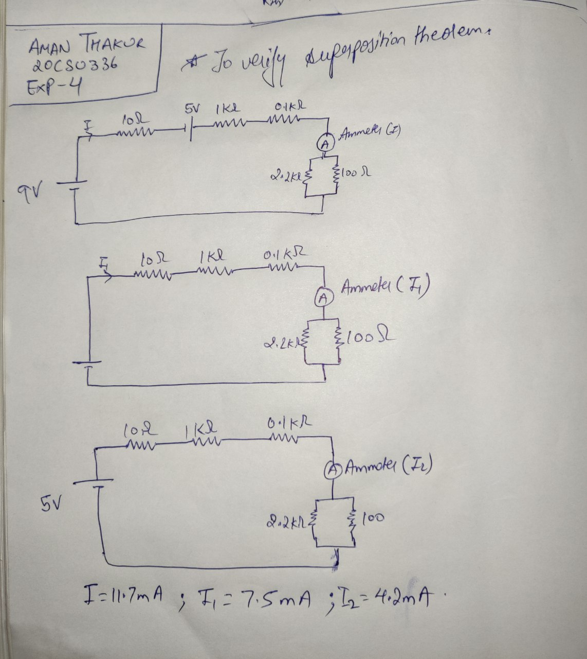

**Practical Diagram: -**

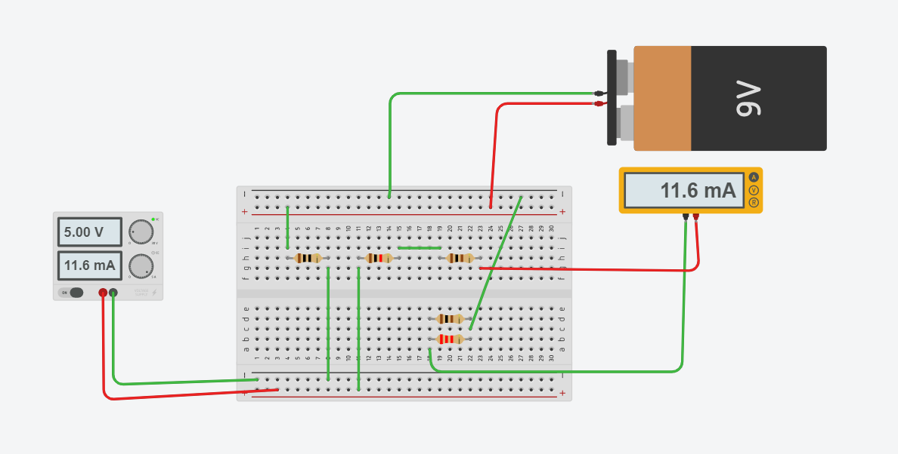

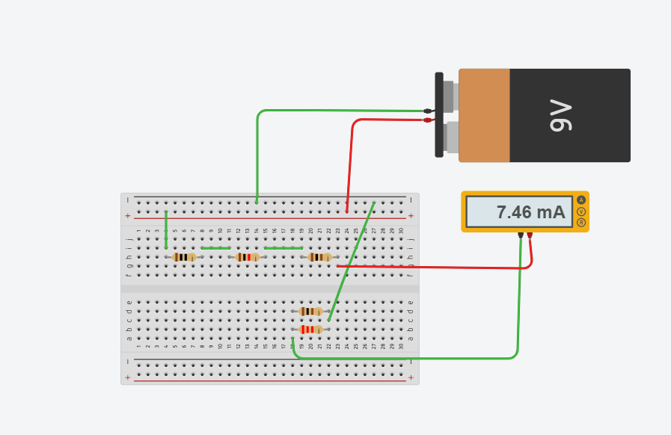

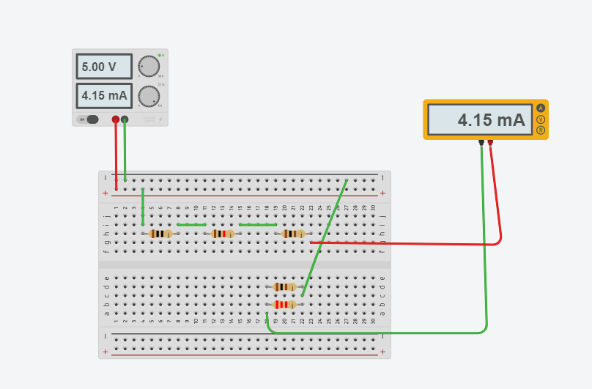

Observations: With the increase in resistance, current and voltage decreases.

I=11.6mA

I1=7.5mA

I2=4.1mA

Result: I= I1+ I2

Hence, superposition theorem verified.